ASSINGMENT – 25

Procedure with cursor

To create a table

Create table emp1(emp_id number,emp_name varchar(30),net_sal number)

Code:

create or replace procedure p_employee is

cursor c_employee is

select emp_id

from emp1;

begin

for i in c_employee

loop

raise_sal(i.emp_id,10);

end loop;

end p_employee;

begin

p_employee;

end;

/

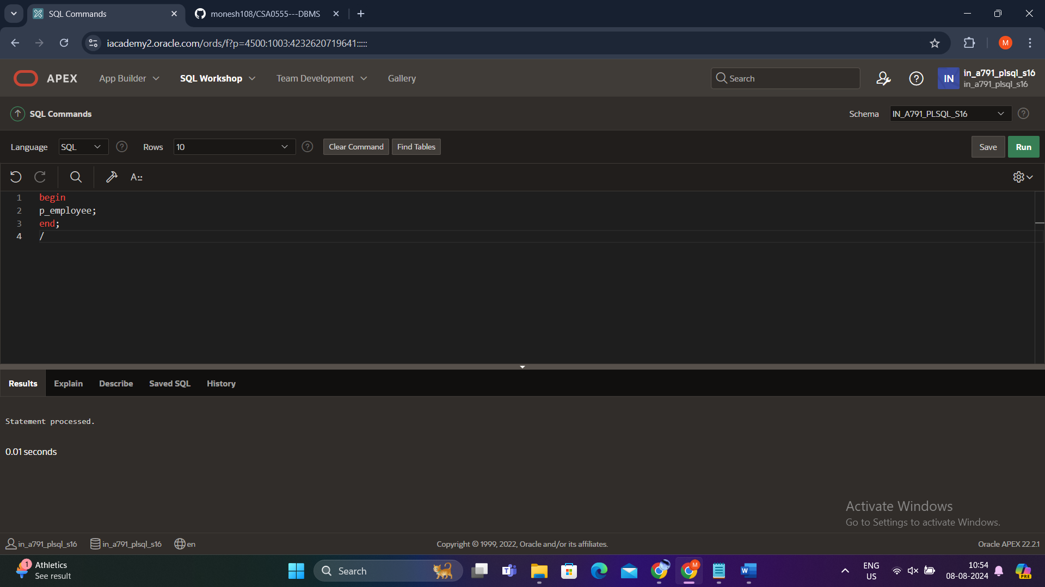

Output:

Select * from emp1;

